Assignment 7: Implementing a Single-Layer Neural Network for Binary Classification
Question 1: Design and Initialize Neural Network
  - Network Design and Truth Table Creation
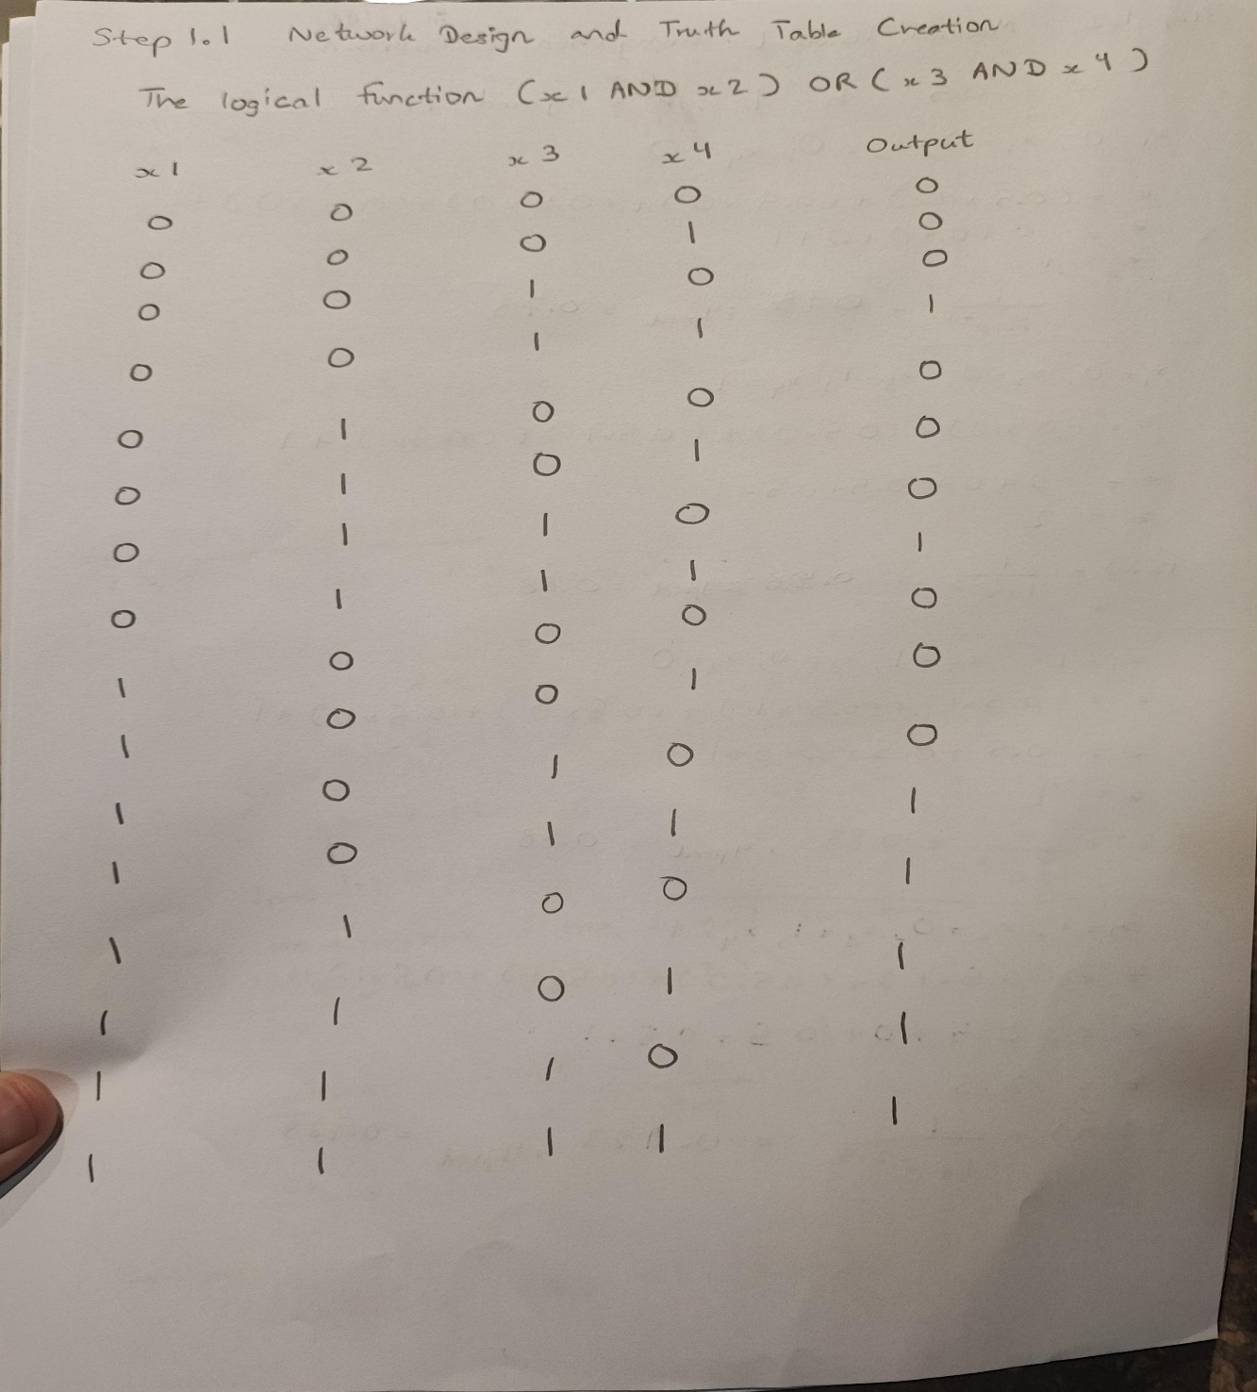
- Creating a truth table and corresponding binary output

  - Manual Forward Propagation Calculation
- I choose example set of inputs from my truth are
x1=0, x2=0, x3=0, x4=0 and x1=0, x2=0, x3=1, x4=1 and x1=1, x2=1, x3=0, x4=0 and x1=1, x2=0, x3=1, x4=1
- Using sigmoid activation function and weight=0.5, bias = 1
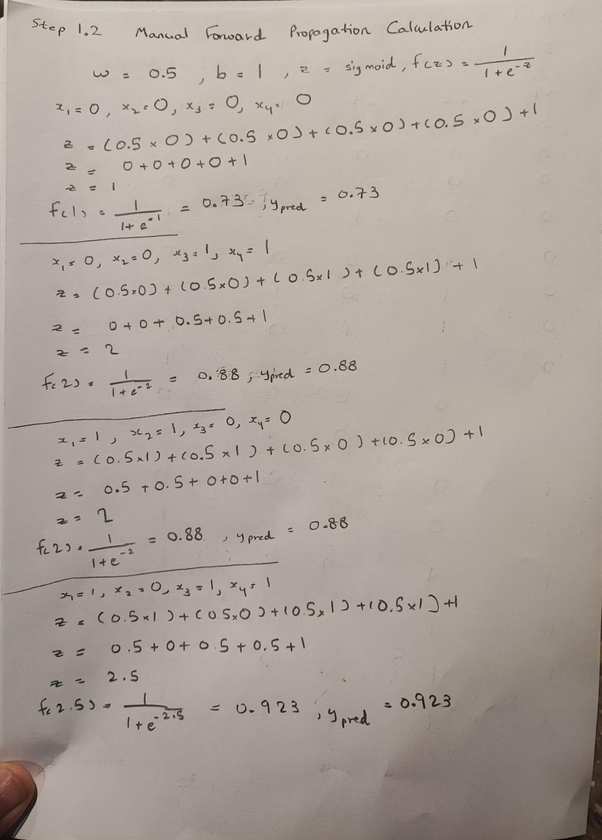

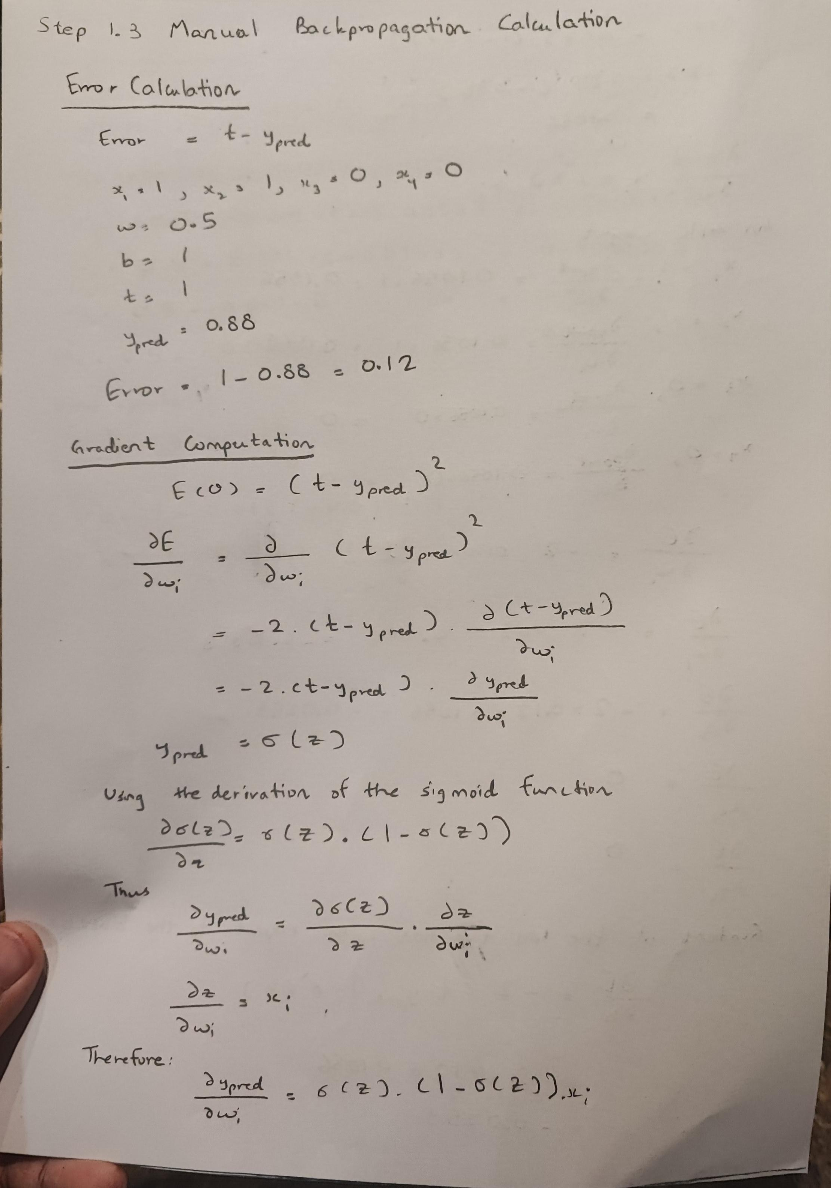
  - Manual Backpropagation Calculation

Error = 0.12
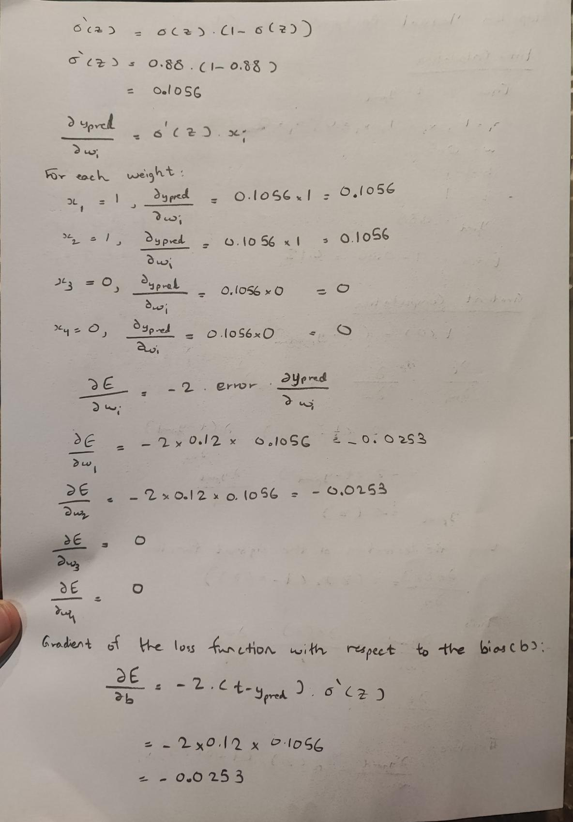Gradient value = -0.0253
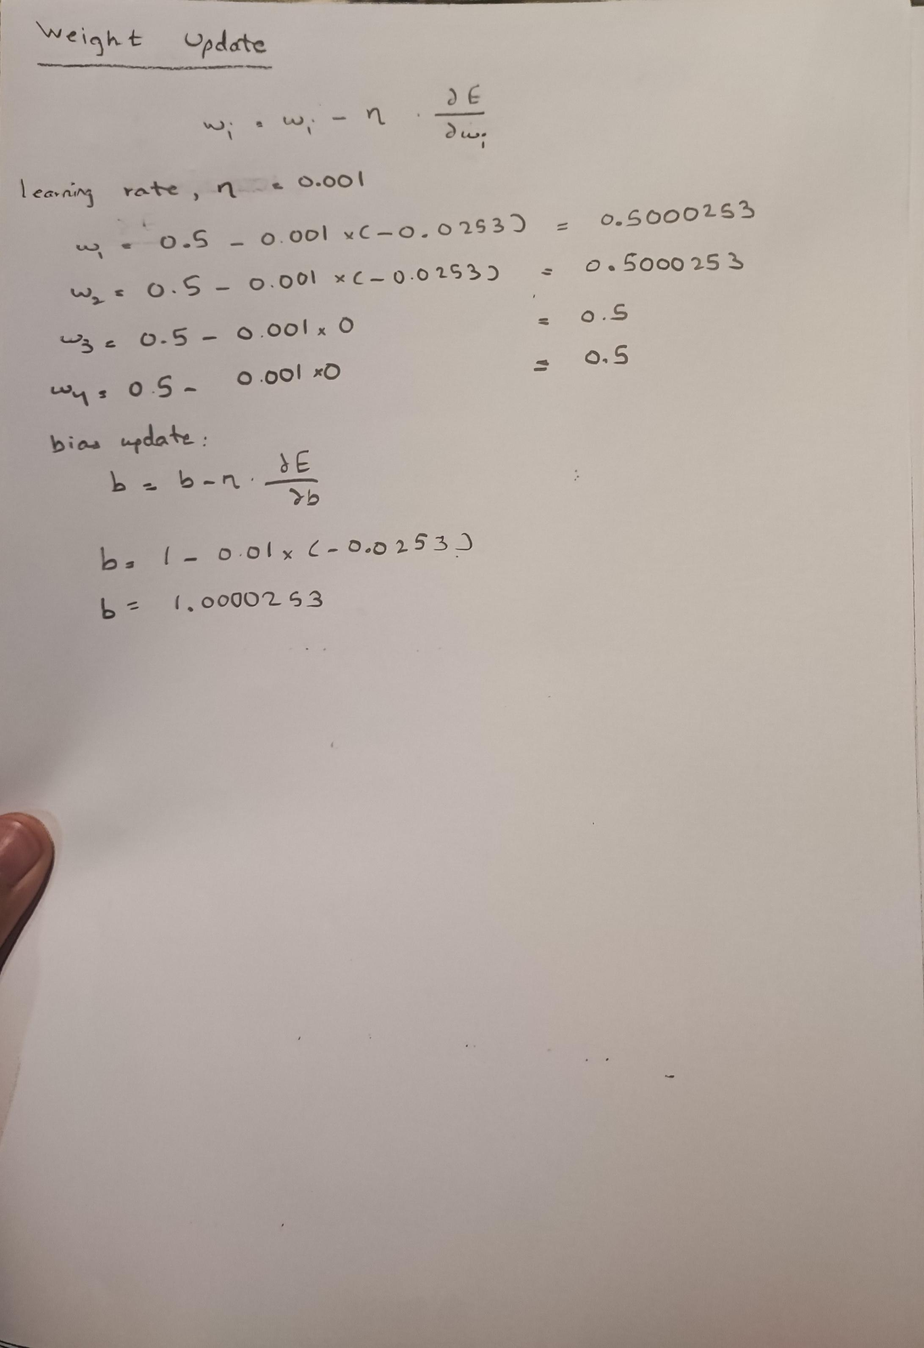
weight update value using learning rate 0.001
  - Implementation and Training in Python
